LUTHERAN CHURCH IN MALAYSIA
LCM Finance Handbook
How to claim money back, get your payslip, apply for and approve leave, verify your ministry's claims, and handle the budget — written for the people who do these things, not the people who built the system.
Contents
Right-click here and choose Update Field to build the contents.

Getting in
The app lives at one address. There is no password to remember and none to lose — you sign in either with your church Google account or with a link emailed to you.
finance-pv.vercel.app
Open it in any browser, on a phone or a computer. Bookmark it the first time.
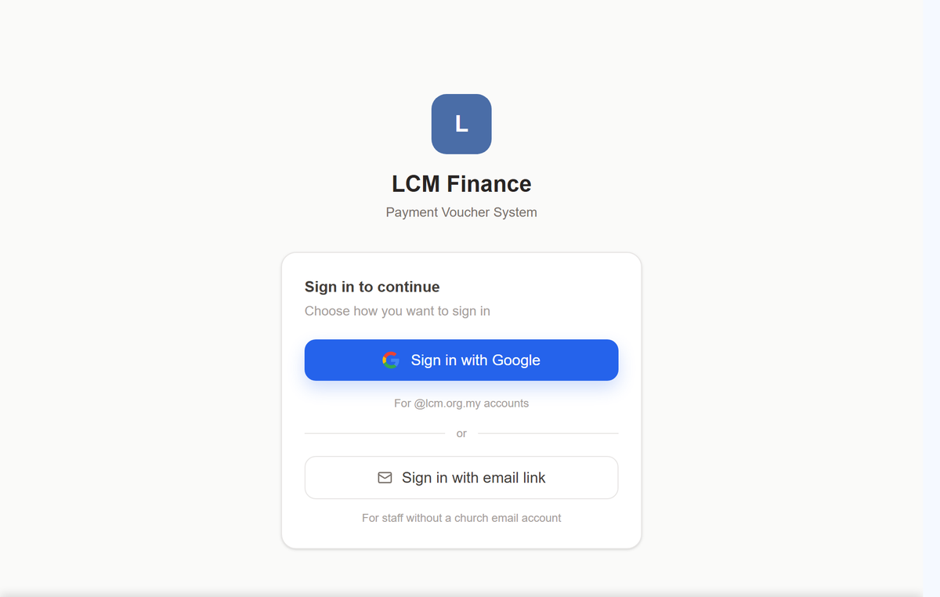
The sign-in screen. Two buttons, and which one is yours depends only on whether the church has given you an @lcm.org.my mailbox.
1 Sign in with Google — if you have an @lcm.org.my address. One tap, the same as opening your church email. Nothing to type.
2 Sign in with email link — if you do not. Type the address the church has for you, and a link arrives in your inbox. Click it and you are in. The link is for you alone and stops working once used, so do not forward it.
Nothing happens when you click? Check the address the church holds for you can actually receive email. A mailbox that was never really set up is the usual reason a link never arrives — ask the Finance Executive to correct it, rather than trying again.

The first time you sign in
You do not create an account and you do not wait for one. Sign in, and the system records your address there and then as a Guest — the smallest role it has, enough to claim money back and to read the church directory, and nothing more. If you should have more than that, somebody at HQ raises your role under Settings → Access & Roles. It takes effect the next time you load a page; you do not have to sign in again, and you do not have to ask twice.
Anybody can sign in, and what they get is a guest. The email-link box accepts any address, and the link really will arrive and really will work. That is deliberate, and it is a floor rather than a door: a guest may ask to be paid back and read the church’s structure, and that is the whole of it. No budgets, no bank accounts, no payroll, nobody’s details, and no claim but their own. Anything above a guest is given by HQ and cannot be taken by signing in.

Checking you are in the right account
Some people have two addresses — their own and an office one, like stewardship@lcm.org.my. Either will sign you in to the same account, but it is worth a glance the first time.
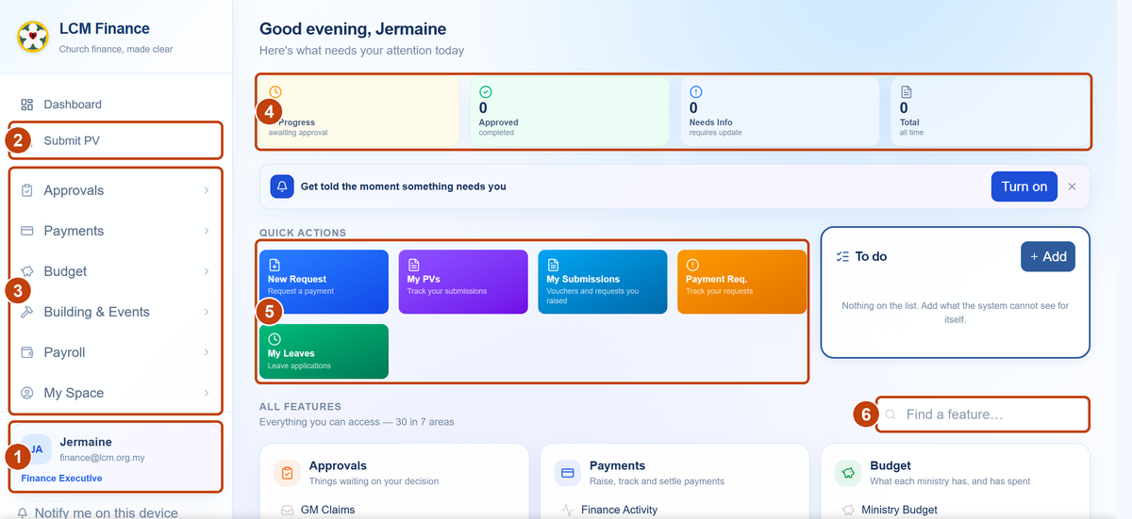
What you land on, with the six things worth knowing marked.
1 Who you are. Your name, the address you signed in with, and your role. Everything else on the page is decided by that role, so if it is wrong, stop here and ask rather than working around it. On a phone these three lines sit across the top of every page instead.
2 Submit PV — claim money back, or ask the church to pay someone. The thing most people come here to do, which is why it sits on its own above the menu.
3 The menu, grouped by purpose. Approvals is what is waiting on you; Payments is money going out; My Space is your own pay, leave and submissions. Click a group to open it. You only see the groups your role can use, so a short menu is not a fault.
4 Your four counters. In progress, approved, needs information, and the total. These count your work, not the church’s — a Finance Executive does not see the whole church’s vouchers here.
5 Quick actions. The same pages as the menu, one click nearer, for the handful done most often. To do beside them is your own list, for the things the system cannot know about.
6 Find a feature. Type what you want — “leave”, “payslip”, “budget” — rather than hunting the menu. Underneath it is every page you can reach, grouped by area, which is the quickest way to learn what your role includes.
Signing out. At the foot of the menu, under your name. On a shared computer, sign out — the app stays signed in for a long time on purpose, so that the people who use it once a month are not locked out.

What your role can do
The left-hand menu is built from your role, so it shows you your own work and nothing else. Find yourself below. If a page named later in this handbook is not in your menu, that part is not yours to do — nothing is broken.
Pastor
- Claim money back
- See your allowances and what is left
- See your pay and download payslips
- Apply for leave
- Approve leave, if you are a head pastor

Dean
- Everything a pastor does
- Sign the leave of pastors in your district

Guest
- Claim money back
- Follow your own claim
- Read the church directory and who holds office

EXCO member
- Verify your ministry's claims
- Propose the annual budget
- Request changes to an approved budget

Treasurer
- Sign payment vouchers
- Approve ministry budgets
- Decide budget change requests

General Manager
- Approve payment requests
- Approve staff leave
- See every claim and every balance

One rule worth knowing first
Anyone may claim money back — pastors, EXCO members, volunteers. Being owed money is not an employment matter. Leave and staff loans are different: they are employment entitlements, so they appear only for people actually employed by LCM. A volunteer EXCO member has an @lcm.org.my address but will not see My Leave.

Guests
Some people are owed money by the church without working for it or sitting on the EXCO — a volunteer who bought the refreshments, a contractor owed for a repair, a council member out of pocket for petrol. The Guest role is for exactly that situation, and it is the smallest one in the system — so small that it is what anybody who signs in starts as, until HQ says otherwise.
A guest may raise a payment request, follow it, and read the church’s structure and who currently holds each office. A guest may not see any claim but their own, or anything of the church’s money — no budgets, no bank accounts, no payroll, no other person’s details. Leave, salary and staff loans do not appear at all: those are employment entitlements, and a guest is not employed here.
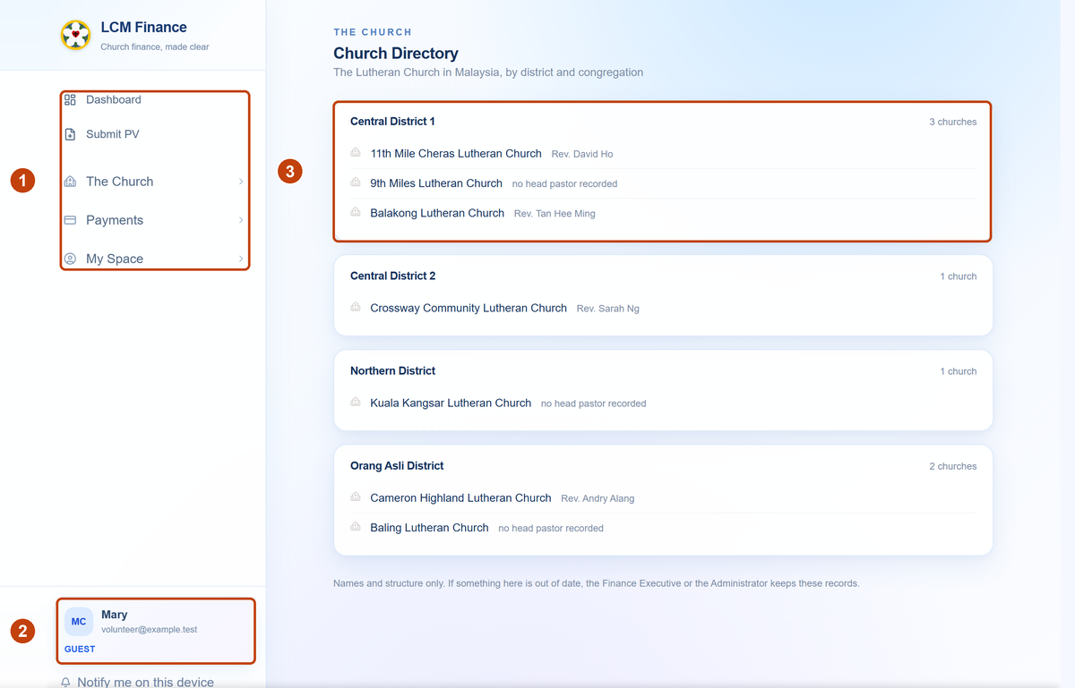
What a guest lands on. A sample directory, not the real one.
1 The whole menu. Five entries, and that is all of it — no Approvals, no Budget, no Payroll, no Administration. A short menu is the role working, not a page that failed to load.
2 Your role, under your name. If this says Guest and you were expecting to approve or verify something, the role is wrong rather than the app — ask before working around it.
3 The church, by district. Every congregation and its head pastor. The Church → Elected Offices alongside it names the Bishop, the Secretary, the Treasurer and each EXCO portfolio. Names and structure only; there are no contact details here for anybody.
A guest’s claim is not a short cut
It goes to the ministry’s own EXCO to verify, exactly as anybody else’s does, and then to the General Manager before Finance raises the voucher. Nothing reaches the finance desk that a member of the church has not vouched for. Follow yours under My Space → My Submissions.

You become a guest by signing in
There is nothing to apply for and nobody to wait for: sign in with the email-link button and you are a guest from that moment. What has to be given is anything more than a guest. Ask the Finance Executive or the Administrator for it, and give them the address you actually signed in with — a role set against a different address will not find you.

How an approval works
Every payment travels the same road, whoever raised it. Four stops. Nothing skips a stop, and nothing moves backwards except deliberately, by somebody who says why.
STOP 1 Finance checks it
The Finance Executive at HQ reads what was submitted: the amount, the ministry it is drawn against, whether there is a budget for it, and whether the receipts are attached. They are not deciding whether the church should spend the money — they are deciding whether the paperwork can be relied on.
STOP 2 The ministry verifies it
The EXCO member holding that portfolio confirms it is their ministry’s spending and that they asked for it. See The EXCO.
STOP 3 The General Manager approves it
The GM releases it to the signatories. Until this point nobody has committed the church to anything.
STOP 4 The officers sign it
The Treasurer, the Bishop and the Secretary. How many of them sign depends on the amount — see below. Once signed, Finance pays it and records the reference.

How many signatures
Set by the church’s own limits of authority, not by the app.
The payment | Signatures | Who may give them
Up to RM 30,000 | 1 | The Treasurer
Over RM 30,000 | 2 | Any two of the Treasurer, the Bishop, the Secretary
Buying an asset over RM 100,000 | 2 | Any two of the same three, and the EXCO must have agreed to it

The voucher itself shows where it has got to and what it is still waiting for, so you never have to ask anybody. Your own are under My Space → My Submissions.
Rejected is not the end. A rejection comes with a reason and sends the voucher back to whoever raised it. Fix what was wrong and submit it again — it keeps its history, so nobody has to be told the story twice.

The EXCO: asking, and verifying
An EXCO member holds one portfolio — Mission, Education, Property, Stewardship and so on — and does two separate things with money: asks for it before it is spent, and confirms spending that has already been claimed against their ministry.

Asking for a payment
Payments → Payment Requests → New Request. Use this when the church has not yet paid and you want it to: a contractor’s quotation, a speaker’s fee, a purchase your committee has agreed to.
- Say who is to be paid, how much, and which ministry and budget line it comes from.
- Attach the quotation or invoice.
- Submit. Your ministry’s EXCO member is told at once.
Once verified it goes to the General Manager. When he accepts it, it becomes a claim on his list and the Finance Executive raises the actual voucher from it — you do not raise a second thing.
If your ministry has no EXCO member in office, the General Manager can approve the request himself, and the record says so plainly: approved without EXCO verification — no member in office. A request is never left waiting on a post nobody holds.

Verifying your ministry’s spending
Approvals → EXCO Queue. What is waiting on you, and nothing else.
You are answering one question: is this ours, and did we ask for it? You are not checking the arithmetic — Finance has done that — and you are not deciding whether the church can afford it, which is the Treasurer’s. The card shows what the payment does to your ministry’s budget before you decide, including when it is Unbudgeted, which is worth a pause rather than a refusal.
If your committee agreed it in a meeting and nobody wants to sign in for it, tell the Finance Executive. They can record the committee’s decision on your behalf, and the voucher will name who decided and on what basis. That is a record of what happened, not a way round you.

The HQ office
Four posts handle every payment between them, and the separation is the point: the person who checks the paperwork is not the person who approves the spending, and neither of them signs.

The Finance Executive
Payments → Finance Activity shows every voucher at every stage, in three panes: the queue, the record, and the voucher itself. Reviewing a voucher means confirming the paperwork stands up — the payee, the amount, the receipts, the budget line.
- Review sends it on to the General Manager.
- Send on without the committee stops waiting for a ministry that is not responding. They are still told, and can still sign afterwards.
- Pull it back for editing undoes a review and any signatures given, and returns the voucher to your queue. Use it deliberately — it clears officers’ signatures.
- Record the committee’s verification puts a ministry’s offline decision on the voucher, with the name of who decided.
The reference and the account code are typed, not generated
The office reference and the account code on every voucher are the church’s own filing, so Finance enters them rather than the system inventing them. The field suggests the next number in the series, keeping the shape of the last one — the prefix, the width, any suffix — and says so if a number is already used or one has been skipped.
It will not stop you. The suggestion is help with the running numbers, not a rule, and a series that needs to jump can jump. The voucher itself shows what Finance entered, never the system’s own internal number.

After the officers have signed, Payments → Payments is where a voucher is marked paid and the bank reference recorded.

The General Manager
Approvals → Signatory Queue, first tab: Needs your approval. These are vouchers Finance has reviewed and that are waiting on you to release them to the officers. The second tab, With the signatories, is what you have already approved — nothing there is asking anything of you.
The GM cannot approve a voucher Finance has not yet reviewed. That is deliberate: the check and the approval are two different acts by two different people, and collapsing them would leave the church with neither.
Approvals → GM Claims holds payment requests you have accepted, waiting for Finance to raise the voucher.

The three signatories
The Treasurer, the Bishop and the Secretary. Everything waiting on you is at Approvals → Signatory Queue under Needs your signature.
- Open the voucher and read it — the document itself is on the page, not behind a download.
- Press Approve or Reject.
- Enter your six-digit PIN. The PIN is your signature; it is what makes the approval yours.
You set your PIN the first time you approve anything, or from Set my PIN at the top of the queue. Nobody, including the people who built the system, can see it or set it for you.
Changed your mind? Retract takes your signature back off, so long as the voucher has not been paid. It is on the voucher where you signed it.

Two of you may be enough. Over RM 30,000 a voucher needs two of the three officers — whichever two get to it. Under that, the Treasurer alone. So a voucher can complete without reaching you, and finding one already approved is not a sign that something was missed.

The form, on a computer and on a phone
There is one form, and it does both jobs. Submit PV is where you claim money back and where you ask the church to pay somebody else — the same page, the same questions. What it becomes when you press the button depends on who you are, not on which form you picked.
1 Most people see “New Payment Request”. What you send is a request: your ministry’s EXCO verifies it, the General Manager approves it, and Finance then raises the voucher and pays. The form takes you through that chain rather than round it.
2 The Finance Executive and the General Manager see “Submit Payment Voucher”. They may raise a voucher directly, so for them the same form ends one stop further along.
The form looks different on a computer and on a phone, and that is deliberate. Nothing is left out of either — they ask exactly the same questions and produce exactly the same document. The app decides by the width of the screen: narrower than about 768 pixels gets the phone layout, anything wider gets the paper one. A tablet held sideways will usually get the computer version. It is not a setting, and there is nothing for you to switch.

On a computer
It is laid out as the printed voucher, in English and Chinese side by side, so that anyone who has filled in the paper form already knows where everything goes.
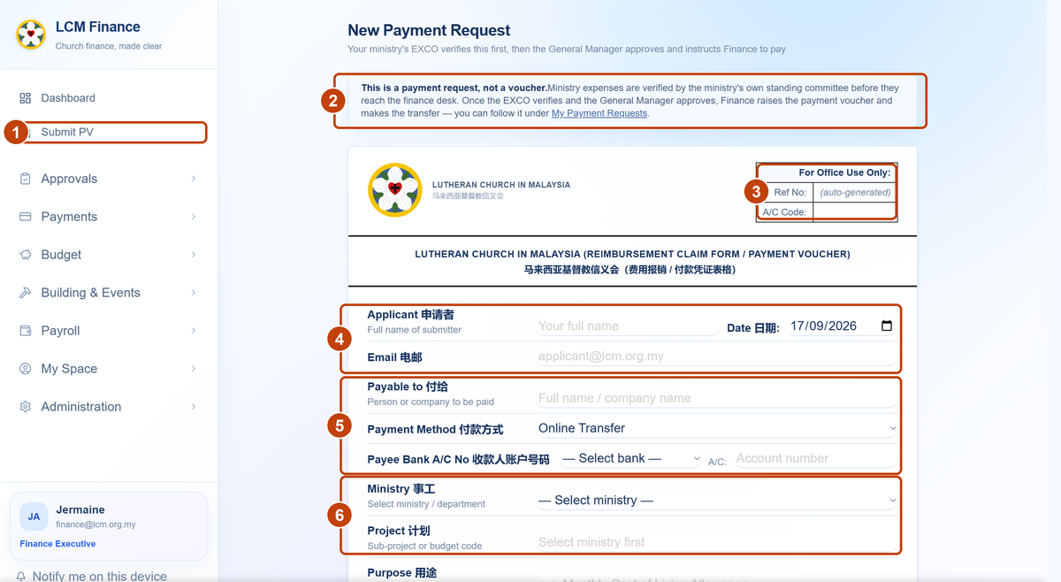
The top of the form on a computer. It continues below the picture with the claim items, the receipts and the declaration.
1 Submit PV — where you start, pinned near the top of the menu for everyone. You do not need a special role for it: being owed money is not an employment matter.
2 What this is. The band at the top tells you plainly that you are raising a request and not a voucher, and where to watch it afterwards. Worth reading once — it is the whole of How an approval works in three lines.
3 For Office Use Only. Leave it alone. Both the reference number and the account code are Finance’s to fill in — they are the church’s own filing, typed rather than generated, so the box stays empty until it reaches them.
4 Applicant, email and date. Taken from the account you signed in with. If the name here is not yours, you are in somebody else’s session — stop and check rather than typing over it.
5 Who is being paid, and how. If the money is coming back to you, this is your own name, your own bank and your own account number. Choose the bank from the list rather than typing it: the payment is made from exactly what you put here.
6 Ministry and project. This decides whose budget the money comes out of, so it is the one part worth asking about if you are unsure. The project list stays empty until a ministry is chosen. Purpose, the row underneath, is what somebody reading the voucher in two years’ time will have to understand.
Below what the picture shows, in this order:
- Claim Items.
One line per thing, each with a date, a description and an amount. Travel has its own kind of line — petrol, train ticket, airfare, or mileage at RM 0.70 a kilometre — with a from and a to. Places you have used before are offered again next time.
- Supporting Documents.
Receipts, invoices, bills. It is marked optional because a handful of payments genuinely have none, but a claim for money you have already spent will come back to you without them. Photographs from your phone are fine.
- Declaration.
Your full name, your signature drawn with the mouse or the trackpad, and a tick to confirm. This is the part that makes the claim yours.
Above the button the form adds up the total and tells you how many signatures that amount will need, so there is no surprise later — see How many signatures.

On a phone
The same form, folded into six numbered steps so that a few questions face you at a time instead of twenty. Tap a heading to open it, tap another to move on. You are not held to the order, and nothing is left out — only folded.
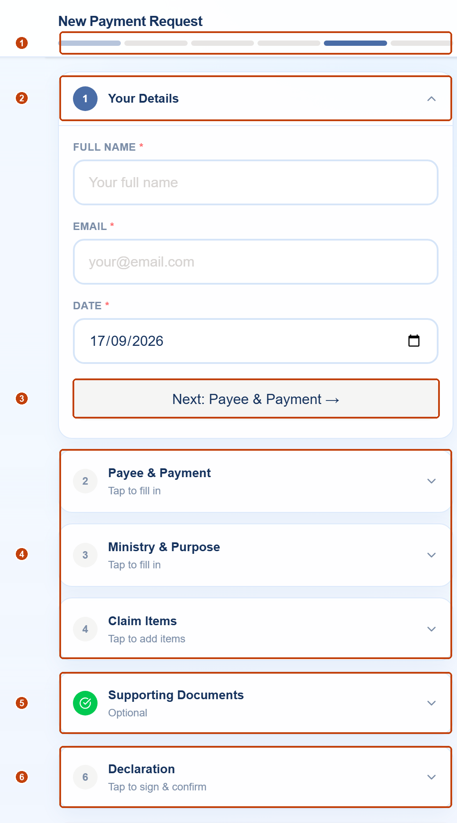
The phone layout, with step 1 open and the rest folded away.
1 Six segments, one per step. A segment fills in as its step is finished, so you can see at a glance how much is left. It is the same six steps every time.
2 The open step. Its number is blue while you are in it and becomes a green tick once the step has what it needs. Tap the heading again to fold it away.
3 Next. Closes this step and opens the following one. It is a convenience, not a gate — you may go back to any step at any time.
4 The folded steps say Tap to fill in until you have filled them, and afterwards show what you entered — the payee and method, the ministry, the total. That one line is how you check your own work without opening anything.
5 Supporting Documents is marked Optional, so it carries a green tick from the start. The tick means the step is not blocking you, not that receipts do not matter. Attach them.
6 Declaration — tap to sign & confirm. The last step, and the only one the phone will not let you past.
Sign with your fingertip. Step 6 asks you to draw your signature on the screen. It does not have to match the one your bank holds — it has to be made by you. On a phone the form will not submit without it.

Finish it in one sitting. What you type lives in the page until you press submit; it is not saved as you go. Closing the tab, or starting on your phone and finishing at your desk, means starting again. If your receipts are not to hand, come back later rather than leaving the form open and hoping.

Whichever shape you filled in, pressing submit puts the same thing into the same queue, and you can follow it under My Space → My Submissions. What happens to it from there is How an approval works.

Claiming money back
You paid for something out of your own pocket — petrol, refreshments, a repair — and you want the church to pay you back. Use Submit PV, which sits at the top of the menu for everyone.
- Open Submit PV.
It is pinned to the top of the left-hand menu, under the Dashboard.
- Fill in who is being paid.
If the money is coming back to you, that is your own name, your own bank and your own account number. The form is in English and Chinese, side by side.
- Choose the ministry and project.
This decides whose budget the money comes out of, so it matters. If you are not sure, ask your EXCO member before submitting rather than guessing.
- List what you spent, line by line.
One line per item, each with a date, a description and an amount. For travel there is a separate mileage section with "from" and "to".
- Attach your receipts.
A claim without receipts will come back to you. Photographs from your phone are fine.
- Sign and submit.
Tick the confirmation and type your name. You will get a voucher number — write it down, or find it later under My Space → My Submissions.

What happens next
Your claim now travels through a fixed chain. You can watch it at any time under My Space → My Submissions. These are the exact words you will see on the screen:
Pending EXCO Review
Waiting for the EXCO member responsible for that ministry. This stage is skipped if the ministry has no head recorded, or if you are that head.
Pending Finance Review
With the Finance Executive, who checks the receipts, the budget line and the bank details.
Ministry Verified
Checked and ready for signature.
Pending Signatory
With the Treasurer — and with a second officer if the amount is above RM30,000. See below.
Approved
Signed. Now waiting for Finance to actually make the payment.
Paid
The money has gone out, and the payment reference is on the voucher.

How many signatures your claim needs
This is set by the church's limits of authority, and the app applies it automatically from the amount. You do not choose it.
Up to RM30,000 One signature — the Treasurer.
Above RM30,000 Two signatures — any two of the Bishop, Secretary and Treasurer.
Assets over RM100,000 Two signatures, and it goes to EXCO.

Asking the church to pay someone else
If you have not spent the money yet and you want the church to pay a supplier from your ministry's budget, that is a different form: Payments → Payment Requests. It goes to your own EXCO first, then to the General Manager, and Finance raises the voucher for you at the end.
Awaiting EXCO verification
Your ministry's own committee agrees the spending.
With the General Manager
The GM approves and instructs Finance.
Approved — Finance raising PV
Finance prepares the voucher.
PV raised
From here it follows the signature chain above. Because your EXCO has already verified it, it is not sent back to them a second time.
Which form do I use?
Money already spent, and you want it back — Submit PV.
Money not yet spent, and the church should pay directly — Payment Request.

Verifying your ministry's claims
For EXCO members and anyone appointed to verify on their behalf. Your committee's claims wait for you at Approvals → EXCO Queue, and nothing moves until you act.
- Open Approvals → EXCO Queue.
Everything shown is waiting on you. The number on the menu item is the count.
- Read the card before you open anything.
Each card already shows the ministry, the amount, who is being paid, what it is for, and how much of the budget line is left. That is deliberate — the four things you need are on the card.
- Check the budget line.
The card shows what has been spent and what is still in flight. If a claim would take the line past its limit, that is your decision to make, not the app's.
- Press Verify or Reject.
Verifying sends it onward. Rejecting sends it back to the person who raised it — always give a reason, because the reason is what they see.
You cannot verify your own claim
If you raise a claim for a ministry you head, it skips your own review and goes straight to Finance. Nobody verifies themselves.

Appointing somebody to check
Often the person who collects the receipts and raises the claims is not the EXCO Member — a coordinator on the ground, say, who buys for a camp and claims afterwards. An EXCO Member can appoint that person as their checker.
A checker confirms that the particulars are right — that the receipts match the figures, and the spending is what it says it is — before the voucher reaches the EXCO Member. The EXCO Member still verifies it. The check is a step added in front of the existing one, not a replacement for it.
A checker must hold no portfolio
The app refuses to appoint somebody who heads a ministry of their own. A checker who could also verify would be checking their own work, and the second signature would quietly become the same signature. That is why the list of people you can choose from is shorter than the directory.
A voucher the checker raised themselves counts as checked when they send it — again, nobody checks their own work — and goes to the EXCO Member as normal.

Where an EXCO Member wants a particular budget line handled without coming back to them every time, they can delegate that line to the checker. The check then settles that line outright and the voucher moves straight on to Finance. The delegation is per line, so it does not quietly cover the rest of the ministry.
Both the appointment and any delegation are made on the same Approvals → EXCO Queue page.

Signing vouchers
For the Bishop, Secretary and Treasurer. Vouchers waiting for your signature are at Approve Vouchers, at the top of the left-hand list.
Only what has reached you
Since October 2026 the queue holds nothing that is still with the ministry, with Finance or with the General Manager. By the time a voucher appears it has been verified by the EXCO, reviewed by Finance and approved by the General Manager — and the voucher shows each of those, with the name and the date. Before this change a signing officer opened a list of nine vouchers, one of which was theirs.

- Open Approve Vouchers.
On a phone this is a stack of approval cards, one per voucher, in the style of a banking app. Four tabs: what needs your signature, what has been approved, what has been paid, and what was turned down.
- Read the card.
Ministry, amount, who is being paid, what it is for, and the effect on the budget — all on the face of the card, without opening the voucher.
- Open the voucher if you want the detail.
The full voucher shows every line, the receipts, and everyone who has already signed. The signing area sits below the voucher, so you scroll through what you are signing before you sign it.
- Approve with the tick, or reject.
You will be asked for your PIN. That PIN is what puts your name on the record, so do not give it to anyone.
- For a batch, you can approve all at once.
Bulk vouchers show an All button. You can still open and sign the individual vouchers inside a batch one by one if you prefer.

The budget behind the voucher
Each card carries a chip saying how the payment sits against its budget — Within budget with what would be left, Over budget by how much, or Unbudgeted. Tap the chip and it opens, naming the exact line in that ministry’s budget and showing what was approved, what has been spent, what is committed but not yet paid, and what would remain if you sign. The ministry’s overall position is underneath it.
Everything you have ever acted on stays in the Approved, Paid and Rejected tabs of the same page. There used to be a second list under Payments → My Approvals; it showed the same vouchers and offered the same buttons, so it was taken out of the signing officers’ menu.

Your salary and payslips
Everything about your own pay is at My Space → My Salary. You do not need to ask anybody, and you do not need to wait for an email.
- Open My Space → My Salary.
It shows only your own record. Nobody else's pay is visible to you, and yours is not visible to anyone except Finance and the General Manager.
- Read your current monthly pay.
Basic salary and each allowance separately, with the date it took effect.
- Check the salary history.
Every change ever made, with the date, the amount and the reason — so an increment can be checked rather than taken on trust.
- Download any payslip.
One line per month. Press Download and the PDF is built there and then. Past months stay available, so a lost payslip is never a problem again.
- Check your bank account number under "Details on file".
It is the account your salary is paid into, and a wrong digit is the commonest reason a payment fails.
Why the page is read-only
You can see everything and change nothing. A change to your own pay details — your bank account above all — always passes through a Finance Executive. Tell them what needs correcting.

If the page says no payroll record is linked
Most people are now connected — 61 of the 81 on payroll. If you are one of the remaining twenty, it is because the church has no @lcm.org.my address on file for you, so there is nothing to recognise you by. Give a Finance Executive your LCM address and the page will work at your next sign-in.

A payslip only appears once Finance has finalised that month's payroll. A run still being prepared is deliberately hidden, because the figures in it are still moving.

What you may claim
Separate from claiming money back, which is the how. This is the how much — the personal allowances the Terms and Conditions give you, which differ by category. Your own figures, and what is left of them, are at My Space → My Salary.
Claim | Pastor | Parish worker | Office staff
Travel | RM0.70 per km, plus tolls on receipts
Out-patient treatment | In full | Half the bill | In full
Specialist out-patient | Half, max RM80 | — | —
Dental, each year | RM200 | RM200 | RM200
Annual blood test | RM100 | — | —
Books and training, each year | RM800 | RM400 | RM200
Moving, per occasion | RM1,000 | RM1,000 | RM500
Maternity, per birth | Half, max RM500 | Half, max RM500 | Half, max RM500

Claiming against one
- Raise the voucher as usual, at Submit PV.
- Choose the entitlement it draws on.
There is a picker below Purpose. Leave it alone for an ordinary payment from a ministry budget — most vouchers are that, not a personal claim.
- Read what it tells you.
It shows what is left of that allowance this year, and warns if your claim is above it. It does not stop you: the Terms have exceptions and your approvers see the same figures.
How "used" is counted
From your own vouchers, once they are approved or paid. A claim still working its way through the chain has not come off your balance yet, so the figure you see is what has actually been settled.
Allowances given per occasion rather than per year — moving, maternity — show no running total. The church has no way to tell which relocation or which birth a voucher belongs to, so what you see is the ceiling on a single claim.

Applying for leave
Go to My Space → My Leave. The page opens on your balance, and the button to apply is on the same screen.
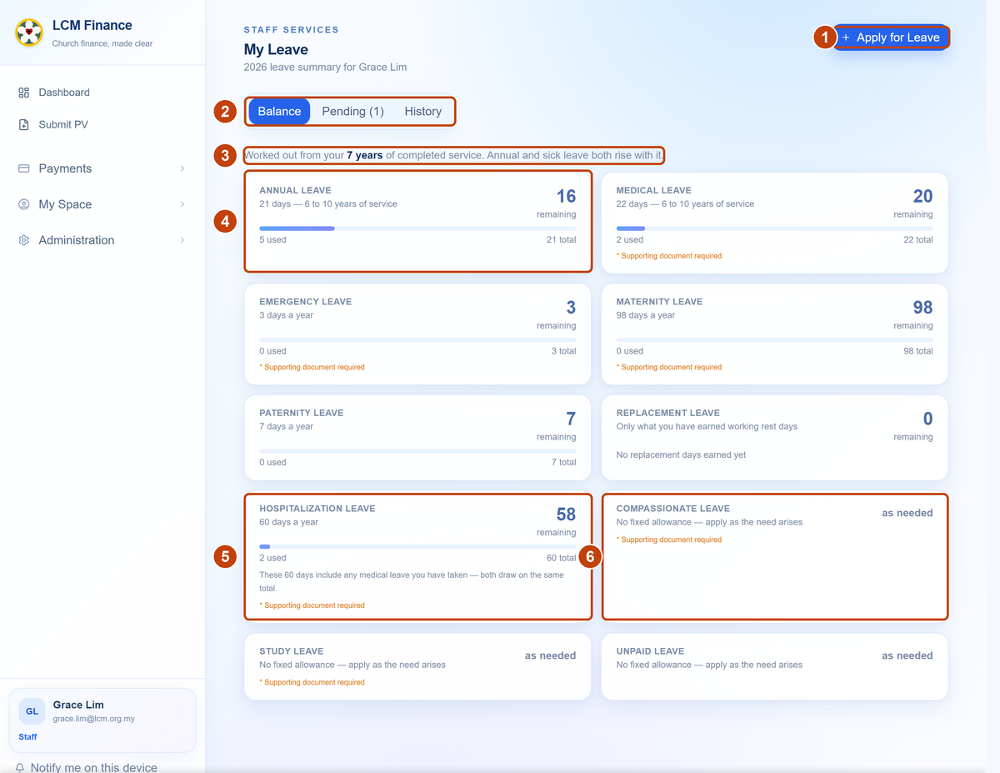
What My Space → My Leave opens on. The figures here are a sample, not a real person’s.
1 Apply for Leave. Top right, on every tab. This is the only way in — there is no separate form to find.
2 Balance, Pending, History. Pending carries a count when something of yours is waiting on somebody, and lists who has signed and who has not. History keeps everything that has been settled.
3 Where the numbers come from. Your completed service, stated plainly. Annual and sick leave both rise with it, so this line explains why your allowance differs from a colleague’s.
4 One card per kind of leave — days left, a bar, days used, and the yearly total. The large figure is what you have left, which is the number worth reading.
5 Hospitalisation counts your sick leave too. The card says so and does the arithmetic: 60 days in all, and here two medical days have already gone, leaving 58. It is not 60 on top.
6 “As needed” is not nothing. Compassionate, study and unpaid leave have no yearly allowance, so there is no balance to show. You still apply for them the same way.
Pastors: showing that you told your congregation
Your congregation is told about your leave but is not asked to approve it, so the only record that you notified them is the one you make. When you apply you will see “Did you tell your congregation?” — attach the letter, the filled form or the email you sent them, or simply type how you told them (“announced at Sunday service, 7 Sep”). Whoever approves your leave sees it before they sign.
It is never required. A pastor who telephoned the chairman has done what the church asks; the note is for saying so.

What you are entitled to each year
Annual and sick leave both rise with your length of service. The same chart applies to pastors, parish workers and office staff alike.
Completed service | Annual leave | Sick leave
Under 2 years | 14 days | 14 days
2 to under 5 years | 14 days | 18 days
5 years | 14 days | 22 days
6 to 10 years | 21 days | 22 days
11 years and over | 25 days | 22 days

Annual leave follows the church's Terms and Conditions (A9.1, B8.1, C7.1); the two charts step at different years because sick leave follows the Employment Act instead, which the Terms are silent on.

The rest
- 60 Hospitalisation
- 3 Emergency
- 98 Maternity
- 7 Paternity
- — Replacement (earned)

Compassionate, study and unpaid leave are also available and have no fixed yearly allowance. Replacement leave is only what you have earned by working on a rest day.
Hospitalisation is 60 days including your sick leave
Not 60 on top of it. If you have already taken 18 days of ordinary sick leave, 42 hospitalisation days remain, and the balance page shows it that way. Both count against the same 60.

Two rules that apply to annual leave only
Nothing in your first six months. Annual leave starts once you have completed six months of service.
Your first year is pro-rated. Join in July and you get half a year's worth. Neither rule touches sick leave, which you have in full from your first day.

- Open My Space → My Leave.
The Balance tab shows each type of leave, how many days you have used and how many are left this year.
- Press Apply and choose the type of leave.
A type marked with an asterisk needs a supporting document — a medical certificate, for example.
- Enter the first and last day.
The app counts working days for you and ignores weekends. Check the number it shows before you continue.
- Give a reason, and attach the document if one is needed.
- Look at who it is going to.
Before you send, the form names the people who will have to sign. If it says no approver could be worked out, stop and ask Finance to check your record.
- Sign and submit.
Your balance at that moment is stored on the application, so the approvers see the same figures you saw.

The form, step by step
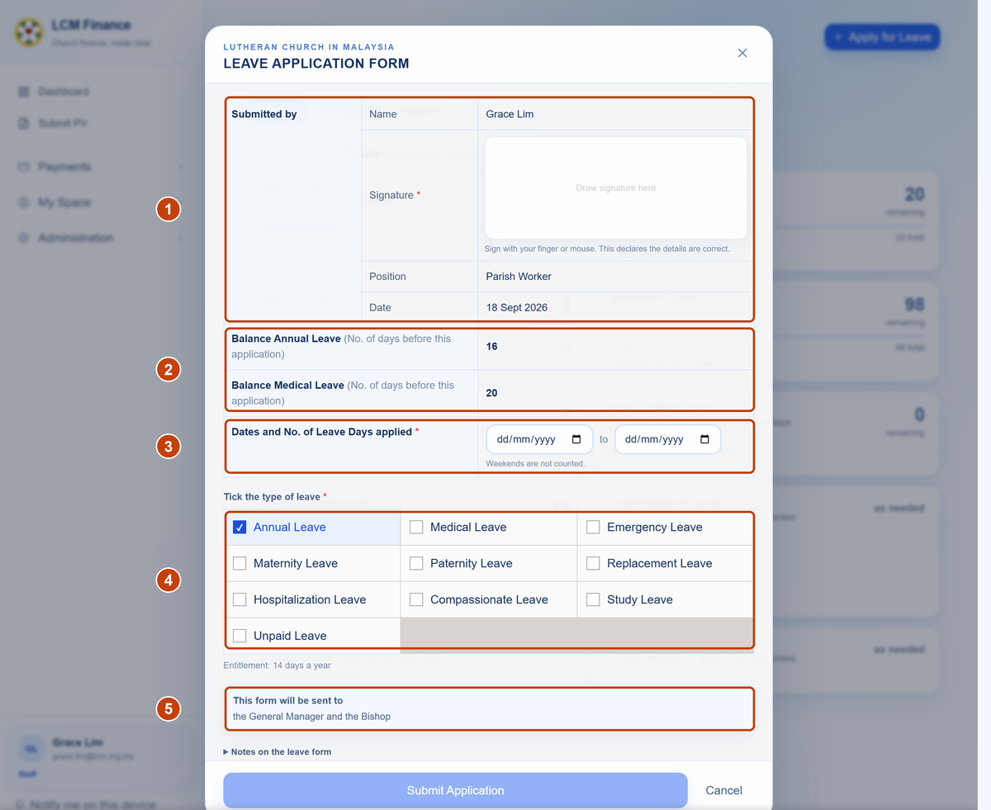
The form itself. It is the church’s printed leave form, kept in the same order, so the paper version and this one can be read side by side.
1 Your name, position and the date are filled in from your record — you do not type them. The signature is drawn here, with a finger on a phone or the mouse on a computer, and it is what turns the form into a declaration.
2 Your balances, as they stand right now. These are copied onto the application when you send it, so whoever signs sees the same figures you saw, not what is left weeks later.
3 First and last day. The app counts the working days between them and ignores weekends. Check the count it gives you before going on.
4 Tick the kind of leave. The ones marked in the balance view as needing a document still need one here — a medical certificate, for instance.
5 Who it will go to, before you send it. This is the part worth reading. If it names the wrong people, or says no approver could be worked out, stop and ask Finance to check your record rather than sending it anyway.
Seven days' notice for annual leave
Applying for annual leave with less than seven days' notice shows a warning, but it does not stop you submitting. The rule has exceptions, and your approvers can see the dates and judge for themselves.

Track it under the Pending tab, which lists who has signed and who has not. Past applications stay under History.

Approving leave
Applications waiting on you are at Approvals → Leave Queue. Who has to sign depends on who is applying — a pastor's leave is not routed like a staff member's.
If the applicant is the Bishop
Nobody signs. The Bishop does not ask for leave — he informs the church. It is granted the moment he submits it, and everyone with an account is emailed that he will be away.
If the applicant is a Pastor
- Their congregation’s Pastor in Charge, then
- Their district Dean
In that order. The Dean is not asked until the Pastor in Charge has signed. A rung nobody fills is skipped rather than blocking — most congregations have no Pastor in Charge recorded, so most pastors’ leave goes to the Dean alone.
If the applicant is a Pastor in Charge
- Their district Dean, then
- The Bishop
One rung up from the pastors they sign for.
If the applicant is a Dean
- The Bishop
The Dean answers to the Bishop and to nobody in between. Nobody approves their own leave, so a Dean’s own district does not settle it.
If the applicant is Office staff
- The General Manager, then
- The Bishop
Every full-time member of office staff, Communications and Trustees included. The General Manager first, with the Bishop signing to acknowledge — not one or the other, and not in either order.
If the applicant has a department head
- Their head of department, then
- The General Manager, then
- The Bishop
Somebody who reports to a head of department keeps that signature and gains the General Manager’s beneath it. Recorded per person, because the rules here have no rung for a department head.
Where the routing comes from
Who signs a pastor’s leave is worked out from the church they serve and the district that church sits in. Both are now on record — 49 churches across six districts — which is what lets the chain resolve without anybody typing it in. If your leave goes to the wrong people, the cause is almost always the church recorded against your name; ask Finance or the Administrator to correct it rather than working around it.

How the request reaches you
If you have a login — Dean, head pastor, GM, Bishop — you get an email with a button that opens that exact application, already at the top of your queue. You sign in as normal, because your approval is recorded against your identity.
If you are the Council Chairman or Representative, you are told and not asked. An email tells you the pastor has applied, and there is nothing for you to click — the congregation acknowledges in its own way. Until September 2026 your signature was required, which meant a pastor’s leave could wait on somebody who had never asked to be in a finance system.

Three things worth knowing
Leave is signed in order, not all at once. Until October 2026 a pastor’s leave was settled by any one of three people, whoever reached it first. It is now a chain: each signature is asked for only once the one before it has been given, so every application is read by the person directly above the applicant.
If it is not your turn, there is nothing to press. The application still appears, showing how far it has come and who it is waiting on, but the buttons are not there. Nothing is lost — you are emailed when it reaches you.
Nobody ever signs their own leave. If the applicant would otherwise be one of their own approvers — a head pastor applying for their own leave, for instance — that rung is skipped and the chain goes on to the person above.

When the rules do not fit
A few people have a chain set for them by hand, which overrides everything above. The Secretary is the standing example: he is himself the Pastor in Charge of his congregation, and nobody approves their own leave. The church wants the Bishop and the Dean named explicitly for him, so that is what his application goes to.
If your own chain looks wrong, that is the thing to ask Finance about. An assigned chain is a row they can edit, not something buried in the app.

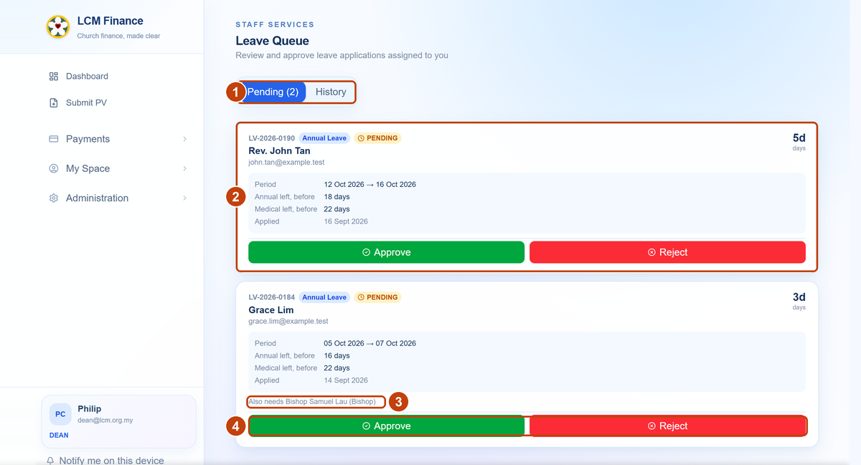
The queue as a Dean sees it, with a pastor’s application above a staff member’s. Sample applications, not real ones.
1 Pending is what is asking something of you. The count is your own list, not the church’s. History holds what you have already settled.
2 A pastor’s leave, with nothing said about anybody else. That silence is the point: the Bishop, the Dean and the Pastor in Charge are alternatives to one another, so whichever of them is reading this settles it alone. The card shows the applicant’s balance as it stood when they applied, so you need not look it up.
3 A staff member’s leave, which does name somebody. Staff chains are different: everybody named has to sign. The line appears only while another signature is genuinely outstanding, so if you see it, approving moves the application along rather than granting it.
4 Approve or Reject. Rejecting asks for a reason, which goes back to the applicant. Approving asks you to sign — see below.

What you see when approving
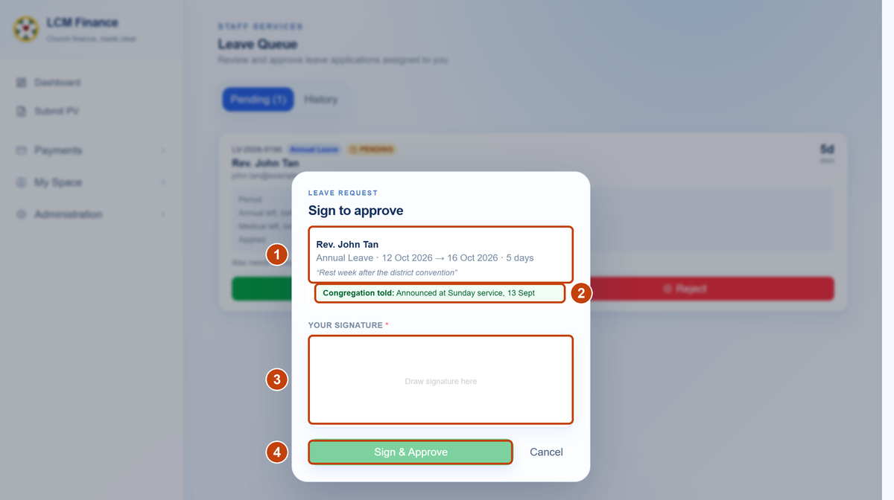
Pressing Approve opens this. Nothing is recorded until it is signed.
1 Who, what and why — the applicant, the kind of leave, the dates, the number of days and their own words for the reason.
2 Whether the congregation was told. Only on a pastor’s application. It shows what they recorded, or says nothing recorded — stated either way, because a blank space tells you nothing. It does not stop you signing; the congregation no longer approves, so this is your only sight of an obligation the pastor still has.
3 Your signature. Drawn here, and required — the button stays inactive until you have signed. It is what makes the approval yours rather than the office’s.
4 Sign & Approve. At this point the applicant is told, and so is anybody else still named on it.
Each application in your queue shows the number of days, the dates, the reason, any document attached, and the applicant's annual and medical balance as it stood when they applied. You do not need to look their balance up separately.
Seeing everyone's balances
A full list of every person's balance, and who has yet to sign, is at Administration → Leave Overview — available to the General Manager, the Administrator and the Finance Executive. Deans and head pastors see balances on the applications they are asked to sign.

The annual budget
For EXCO members and the Treasurer. Everything is at Budget → Ministry Budget. An EXCO member sees their own ministries; the Treasurer, GM, Bishop and Finance see them all.

Reading the budget
The budget is set out the way a set of accounts is: income above expenditure, sub-projects indented under the project they belong to, a subtotal under each section on a rule, and the ministry’s total under a double rule. Five columns of figures, all in ringgit:
Column | What it counts
Budget | What the line was given for the year.
Spent | Vouchers approved and paid.
Committed | Vouchers raised but not yet paid. The number in brackets is how many.
Balance | Budget less Spent. Ignores anything committed.
Available | Budget less Spent less Committed.

Which balance to use
There are two on purpose. Use Available when deciding whether there is room for something new — the committed vouchers are still coming, and Balance does not know about them. Figures shown in red are over budget and in amber are close to it; a healthy line is left in ordinary ink so the ones needing attention are the ones that catch your eye.

Proposing your ministry's budget — EXCO
- Choose your ministry and the year.
Lines you add for a future year belong to that year's proposal until the Treasurer approves them.
- Add each project as a line.
Name, whether it is income or expense, the estimated amount, and any notes. You can attach the supporting paper to the line.
- Add sub-projects underneath a project if you need to.
A line can sit under a parent line, so a large project can be broken down.
- Submit the proposal.
It goes to the Treasurer as a whole — you do not submit lines one at a time.
- Wait. The budget is locked while it is with the Treasurer.
This is intentional: it stops the figures moving underneath the person deciding on them.

Approving a budget — Treasurer
- Open Budget → Ministry Budget.
Submitted proposals from every ministry are listed together, oldest first.
- Read the ministry's lines and the papers attached to them.
- Approve or reject, with a note.
Approving makes the lines live, and claims can then be charged against them. Rejecting unlocks the budget so the ministry can revise it. Your note is what they see.
The Finance Executive can also decide a proposal. That is deliberate — it means a budget is never stuck if the Treasurer is away.

Changing a budget that is already approved
Once a budget is approved, an EXCO member cannot simply edit it. You ask, and someone with authority decides. The three kinds of change — add a line, edit a line, delete a line — all work the same way.
You make the change and save
You fill in the form exactly as if you were editing. Instead of saving, the app records it as a request and tells you so.
The EXCO board is told
Everyone holding an EXCO portfolio is emailed, along with the Treasurer, General Manager, Bishop, Secretary and Finance Executive. A change to an approved budget is the board's business, not a private exchange between your ministry and whoever opens the page next.
Pending
The request sits at the top of the budget page, visible to your ministry and to those who can decide it. Nothing has changed in the budget yet.
Approved or rejected
Decided by the Finance Executive, Treasurer, General Manager, Bishop or Secretary. An approved change is applied to the budget immediately. A rejected one keeps its reason on the record.

Who sees what
If a page is not in your menu, you do not have that duty. This is the short version.
Page | Pastor | Dean | EXCO | Treasurer | GM | Guest
Submit PV | Yes | Yes | Yes | Yes | Yes | Yes
My Submissions | Yes | Yes | Yes | Yes | Yes | Yes
Payment Requests | Yes | Yes | Yes | Yes | Yes | Yes
My Salary | If employed | If employed | If employed | If employed | If employed | —
My Leave | If employed | If employed | If employed | If employed | If employed | —
EXCO Queue | — | — | Yes | — | — | —
Approve Vouchers | — | — | — | Yes | — | —
Leave Queue | Head pastors | Yes | — | — | Yes | —
Ministry Budget | — | — | Own ministries | All | All | —
Leave Overview | — | — | — | — | Yes | —
People Directory | — | — | — | Yes | Yes | —
GM Claims | — | — | — | Yes | Yes | —
The Church | — | — | — | — | — | Yes

The Bishop and Secretary see Approve Vouchers on the same terms as the Treasurer. Finance and the Administrator have their own pages, which are outside this guide. Guest is the role given to somebody owed money who neither works for LCM nor sits on the EXCO — see Guests. The Church is the directory and the list of elected offices, which is offered to guests and to nobody else.
Seeing a page is not the same as being able to change it
The table above says who can open a page. Since October 2026 the signing officers — Bishop, Treasurer and Secretary — read the church’s records and no longer edit them. They can look up anybody in the People Directory, because knowing who somebody is forms part of deciding whether to sign a payment to them; they cannot alter a record, and they cannot change what anybody is allowed to approve. That last one matters most: the role on an account is what decides who may authorise spending.
The church’s records belong to the Administrator, with the Finance Executive and the General Manager alongside. The one exception is the office register — who holds which office, and from when — which is the Secretary’s, because recording elections is the Secretary’s job. Seating somebody in an office moves that office’s role onto their login; the role comes from the office rather than from whoever records it, so an election can be recorded without anybody being able to hand out a rank.

Questions people ask
My claim has said "Pending EXCO Review" for two weeks. What do I do?
It is sitting with the EXCO member for that ministry, and only they can move it. Open the voucher from My Space → My Submissions — it names the person it is waiting on. Ask them directly. If nobody is named, ask Finance to check that the ministry has a head recorded.
What is the difference between Submit PV and a Payment Request?
Submit PV is for money already spent, or a payment you know the full details of. It raises the voucher straight away.
Payment Request is for money not yet spent — you are asking your ministry and then the GM to agree to it, and Finance raises the voucher afterwards.
Why does my claim need two signatures when my colleague's needed one?
The amount. Up to RM30,000 the Treasurer alone signs. Above RM30,000 it needs any two of the Bishop, Secretary and Treasurer. An asset purchase above RM100,000 goes to EXCO. The app works this out from the amount — nobody chooses it.
My claim was rejected. Can I fix it and send it again?
Yes. The rejection carries the reason the approver typed. Correct what they asked for and submit again. Rejection is not a cancellation — it is being sent back to you.
How do I get my payslip?
Download it yourself from My Space → My Salary. Every finalised month is listed, and pressing Download builds the PDF on the spot. Finance can also still send it to you, but you no longer have to ask.
My Salary says no payroll record is linked to my login.
Your pay details exist — your sign-in address just hasn't been matched to them. Ask a Finance Executive to link your People Directory record to your payroll record. Until they do, the page is not permitted to show you anything, which is why it shows nothing rather than an error.
Last month's payslip isn't in the list.
That run has not been finalised yet. Figures in a run still being prepared can change, so they are held back rather than shown as though they were settled. It appears as soon as Finance closes the month.
Why is my leave still waiting when one person has already signed it?
Because the signatures are asked for in order, not all at once. A pastor’s leave goes to the Pastor in Charge of their congregation and then to the district Dean; the Dean is not asked until the first signature is given. Open the application and it will tell you which rung it has reached and who it is now with.
Until October 2026 any one of three people could settle it, whoever reached it first. That is no longer so, which is why an application that would once have been finished can now be halfway. Your congregation is still told and is not asked to approve anything.
Does our Council Chairman have to do anything?
No. They are emailed when a pastor applies, and that is all — there is nothing to click and no account to set up. If you want to show that you told your congregation, attach the letter, the form or the email you sent them when you apply; whoever approves your leave can then see it.
I applied for annual leave with four days' notice. Will it be rejected automatically?
No. You will see a warning about the seven-day rule, but the application still goes through. Your approvers can see the dates and decide. Nothing is blocked automatically.
Who approves the Bishop’s leave?
Nobody, and that is deliberate. The Bishop informs the church rather than asking it: the leave is granted the moment he submits it, and everyone with an account is emailed that he will be away. If you receive one of those there is nothing for you to do — it is for your information.
My form says “no approval needed”. Is that right?
If you are the Bishop, yes. For anybody else the form would say instead that no approver could be worked out, which is a fault — ask Finance to check your record. The two messages are deliberately different so you can tell which one you are looking at.
I am a Dean. Who approves my leave?
The Bishop, and only the Bishop. You are a pastor too, but a Dean's own leave goes straight to the Bishop rather than round the congregation.
Maternity or paternity leave has disappeared from my list.
Each is now offered only to the people the Terms give it to — maternity to a co-worker who has given birth, paternity to one whose wife has. Which you see follows the gender on your directory record. If yours is blank you will see both, and if it is wrong, ask Finance or the Administrator to correct it on your profile.
My annual leave went up this year and nobody told me.
It rises with service: 14 days up to five years, 21 from six to ten, 25 from eleven. The app used to give everybody 14 regardless, so if you have been here more than five years you were being under-credited and are now getting what the Terms and Conditions always said. Sick leave works the same way on a different chart — 14, then 18 at two years, then 22 at five.
How much of my dental or book allowance is left?
My Space → My Salary lists every allowance with what you have used and what remains. The same figures appear on the Submit PV form once you pick which allowance a claim draws on.
I claimed something before and it is not counted.
Claims raised before the allowances were set up carry no tag, so they do not count against a balance. If that matters for your figures, tell Finance which vouchers were personal claims and they can mark them.
How do I see how many days I have left?
My Space → My Leave opens on the Balance tab, which shows every type of leave with days used and days remaining for the current year.
Can I see everyone's leave balance?
Only the General Manager, the Administrator and the Finance Executive have the full list, at Administration → Leave Overview. If you approve leave, you see the applicant's annual and medical balance on the application itself, as it stood when they applied.
Why can't I edit the budget directly? I am the EXCO member for that ministry.
Because it is already approved. An approved budget is a decision of the church, so changing it is a request, not an edit. Fill in the change exactly as if editing — the app records it as a request, tells you it has done so, and emails the EXCO board that you have asked. The Treasurer, General Manager, Bishop, Secretary or Finance Executive then decides it.
Our budget says it is locked and I cannot change anything.
It has been submitted and is with the Treasurer. It unlocks when they approve or reject it. This is deliberate — the figures should not move while somebody is deciding on them.
The budget shows two different balances. Which one do I use?
Balance counts only what has been approved and paid. Available also subtracts vouchers raised but not yet paid. Use Available — the lower one — when deciding whether there is room for new spending, because those vouchers are still coming.
I am an EXCO member but not employed by LCM. Why is there no My Leave for me?
Leave and staff loans are employment entitlements, so they only appear for people employed by the church. Claiming money back is not — you can still raise a voucher for anything you have paid for.
Can I approve my own claim if I am the EXCO member for that ministry?
No, and you will not be asked to. A claim raised by the head of a ministry skips their own review and goes straight to Finance.
My name shows the wrong title — Rev. when I am a Pastor, or the other way round.
The title is not typed anywhere; it comes from whether your record says you are ordained a Reverend or a Pastor. That was read from the church’s own contact list, which writes “Rev.” or “Ps.” in front of each name. If yours is wrong, the record is wrong — ask Finance or the Administrator to change the ordination on your directory entry and every screen follows.
My church, or my district, is wrong.
Ask Finance or the Administrator to correct it in the Church Directory. It is worth doing promptly: your church decides which head pastor and which Dean your leave goes to, so a wrong church quietly sends your applications to the wrong people.
Which of my email addresses does the church use?
Two are held. Your @lcm.org.my address is the one the app writes to — approval requests, payslips, notifications — and for most people it is also how you sign in. Your personal address is kept alongside it so you can still be reached if the LCM one is not working. Some officers sign in with a role address instead (secretary@, treasurer@, and so on); that is deliberate, because the role’s powers are attached to it.
Nothing is in my menu that this guide mentions.
Then that duty is not yours, which is normal — the menu is built from your role. If you believe you should have something and do not, ask Finance to check your record under Access & Roles rather than assuming a fault.

Prepared for the Lutheran Church in Malaysia. Everything here describes the app as it currently behaves. Where a rule has an exception — the seven days’ notice for annual leave, for example — that is said plainly rather than left for you to discover.
Revised October 2026. Leave is now signed in order rather than by whichever approver reaches it first, and office staff go to the General Manager before the Bishop. An EXCO Member may appoint a checker. The office reference and account code on a voucher are typed by Finance rather than generated. The signing officers’ queue holds only what has reached them, and the budget chip on each voucher opens to name the line it is drawn against. The signing officers read the church’s records and no longer change them.
There is also a short guide for each role — EXCO Member, Pastor, Checker, Office Staff, Admin Executive, General Manager, Signing Officer, Finance Executive, Accounts Executive, Building & Event Manager — covering only what that person does. The HQ office can send you yours. This handbook is the whole system in one document, for anybody who needs to see how the parts fit.

